MINOR – II PROJECT
Project-1 Metasploitable Setup & Mutillidae II Fix
Name :- Gulshan Kumar Pandit
Course: Cyber Security
Project: Minor-II project-1

- INTRODUCTION
This report documents the complete setup and configuration of the Metasploitable virtual machine as part of Minor-II Project 1. The objective of this project is to gain hands-on experience with vulnerable systems, Linux user management, snapshot handling, and fixing web application database errors.

- TOOLS & TECHNOLOGIES
- VM WARE WORKSTATION
- METASPLOITABLE2 VIRTUAL MACHINE
- MUTILLIDAE II VULNERABLE WEB APPLICATION

- METASPLOITABLE INSTALLATION & SETUP
Metasploitable 2 was downloaded from the official SourceForge repository and imported into VMware Workstation Player. The network adapter was configured in NAT mode. The default credentials (msfadmin/msfadmin) were used to log in.
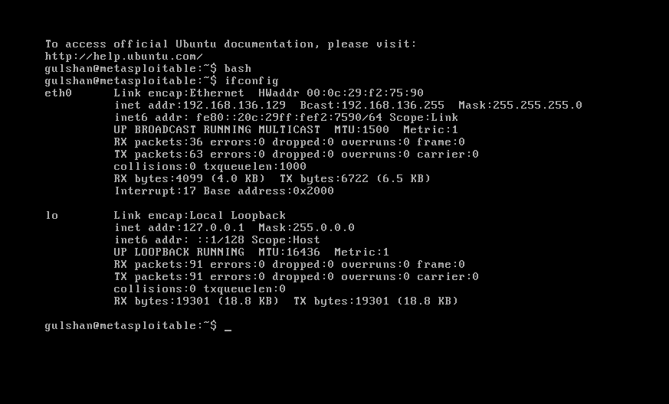

- USER CREATION
A new user was created inside the Metasploitable system using the Linux adduser command. The user was also added to the sudo group to allow administrative access.
COMMAND USED:-
Sudo adduser farhan

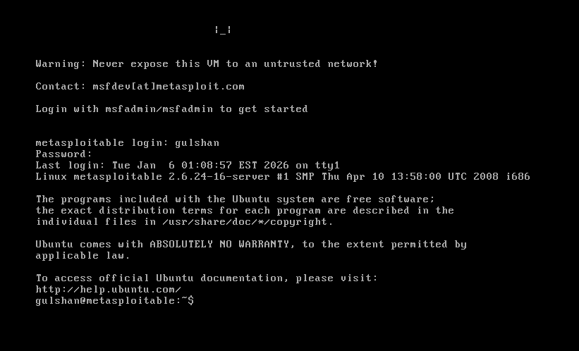

- MUTILLIDAE II DATABASE ERROR FIXING
Initially, Mutillidae II displayed a database connection error. This issue was resolved by using metasplotable2
COMMAND USED:-
sudo nano /var/www/mutillidae/config.inc

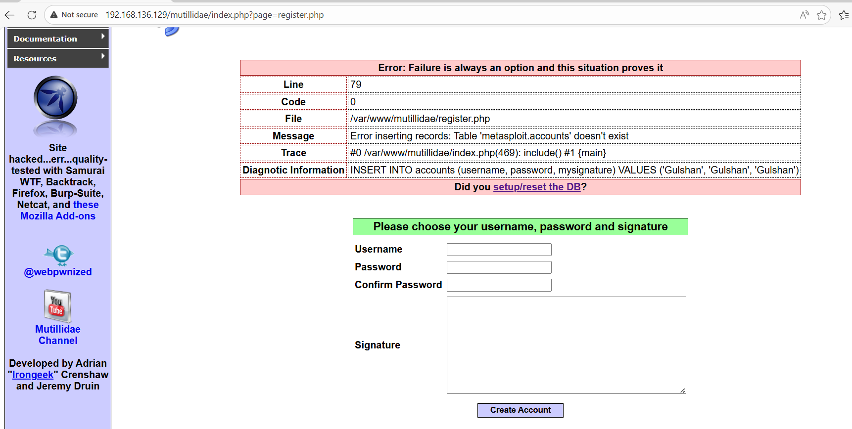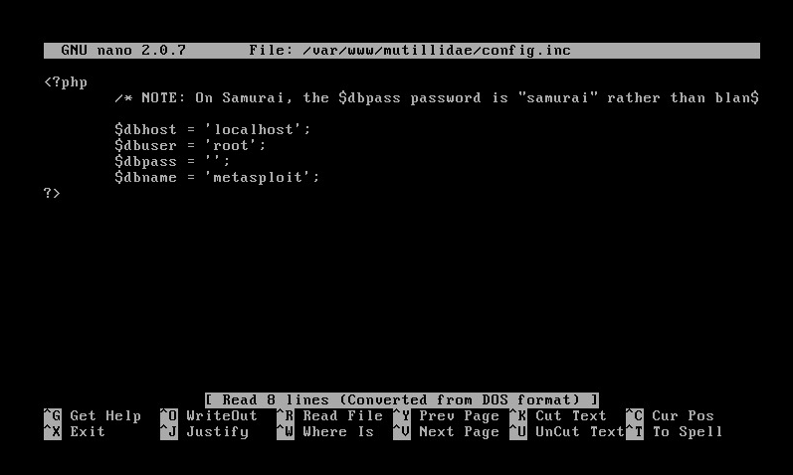
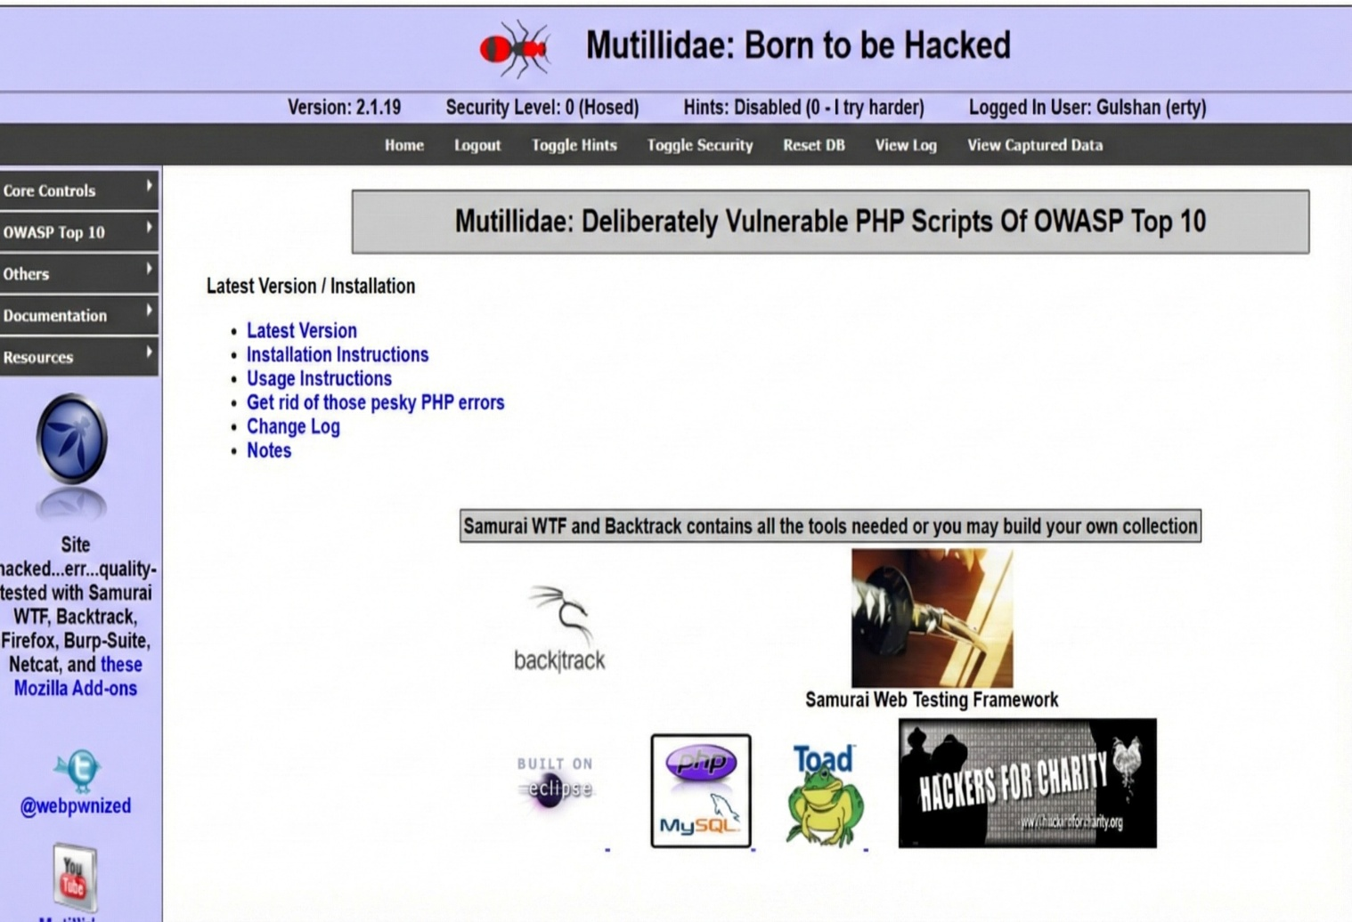
- CONCLUSION
This project successfully demonstrated the installation and configuration of a vulnerable system, basic Linux administration, snapshot management, and troubleshooting of a web application database issue. The objectives of Minor-II Project 1 were achieved successfully.

